**Installation Instructions**

**Developer Instructions:**

1. Download the SFML libraries from <https://www.sfml-dev.org/download/sfml/2.5.1>
2. Choose the Visual C++ 15 (2017) – 64 Bit Download.
3. Install the download files into a SFML directory
4. In Windows go to Control Panel -> System Settings and set the User Environmental Variables. Add the variable SFML_INSTALL_LOCATION and point it towards the directory where SFML was installed.

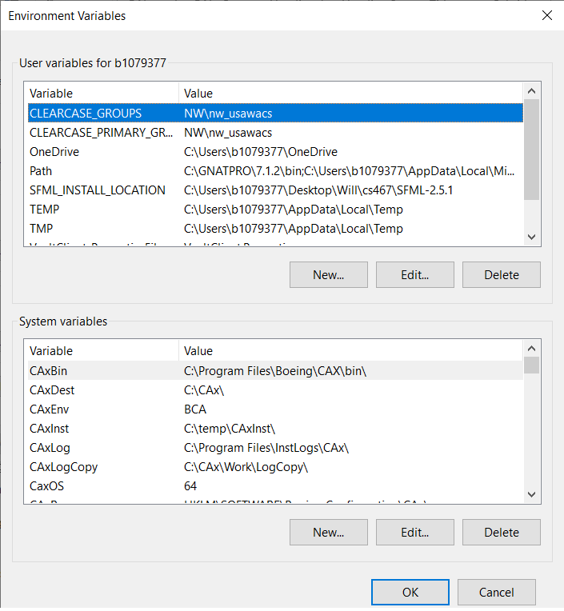

1. Add the line “%SFML_INSTALL_LOCATION%” to the end of the Path variable.
2. Download the project from <https://github.com/muhnkee/AudioLoop>
3. The code may be opened via Visual Studio 17 and more. It may not be compiled, debugged and adjusted as needed.

**Standard Instructions**

1. Download the executable, associated libraries and set it in the directory where you would like to run it out of GitHub from the release: <https://github.com/muhnkee/AudioLoop/releases/tag/midway>
2. Select the executable to load it.